Title (Font size 12 pt., Bold, Exactly 16, Center)

First name Last name¹, First name Last name², First name Last name^{2*} (Font size 10., Bold, Exactly 14, Center)

¹ Department, Institute, City (Font size 10 pt., Regular, Exactly 12, Center)
² Department, Institute, City (Font size 10 pt., Regular, Exactly 12, Center)
*Corresponding author: Name, e-mail address: (Font size 10 pt., Regular, Exactly 12, Center)

Abstract (Font size 12 pt., Bold, Exactly 16, Center)
A single paragraph abstract is limited between 250-300 words. (Font size 11 pt., Regular, Exactly 16; Justify, tab 1.27 cm)
………………………………………………………………………………………………………………………………………………………………………………………………………………………………………………………………………………………………………………………………………………………………………………………………………………………………………………………………………………………………………………………………………………………………………………………………………………………………………………………………………………………………………………………………………………………………………………………………………………………………………………………………………………………………………………………………………………………………………………………………………………………………………………………………………………………………………………………………………………………………………………………………………………………………………………………………………………………………………………………………………………………………………………………………………………………………………………………………………………………………………………

Keywords: Font size 10 pt., Regular, Exactly 14 (up to 5 keywords, each separated with (,))

1. Introduction (Font size 11 pt., Bold, Exactly 16, Left justify)

Introduction should provide problem and its significance. Background of the study and literature review are required in this section. Research objectives need to be stated. Please do not include data and conclusion from the work in this section. References should be cited in numerical order in parentheses (e.g. [1] or [2-4]). (Font size 11 pt., Regular, Justify, Exactly 16, Tab 1.27 cm)

2. Methods and Materials (Font size 11 pt., Bold, Exactly 16, Left justify)

The materials used in the work should be specified. Please identify the equipment (with the manufacturer’s name, city, country in the parentheses). Information of all drugs and chemicals must be provided (with the manufacturer’s name, city, country in the parentheses). Please clearly describe how to select the observational and experimental participants (e.g. healthy, patients, age, sex, etc.). Source of population should be mentioned.
Please describe how and why a study was done in a particular way. The author must provide the procedures in sufficient detail and may use subheading to clarify the study. The unit of measurement must be the same system throughout the paper. If statistical method was used, please describe with enough detail. Modified method from the published work must be described briefly and cited. (Font size 11 pt., Regular, Justify, Exactly 16, Tab 1.27 cm)
2.1 Subheading (Font size 11 pt., Bold, Exactly 16, Left justify, Tab 1.27 cm)
(Font size 11 pt., Regular, Justify, Exactly 16, Tab 1.27 cm)
2.2 Subheading (Font size 11 pt., Bold, Exactly 16, Left justify, Tab 1.27 cm)
(Font size 11 pt., Regular, Justify, Exactly 16, Tab 1.27 cm)

3. Result and Discussion (Font size 11 pt., Bold, Exactly 16, left justify)

Presents your results in the sequence as describe in Methods and Materials section. Authors may use graphs, figures and tables to display the data. Do not repeat all the data in tables or figures in the text, summarize only the most important finding. Discuss the main findings and limitations of your study. Authors should mention the influence of the findings to future research. (Font size 11 pt., Regular, Justify, Exactly 16, Tab 1.27 cm)

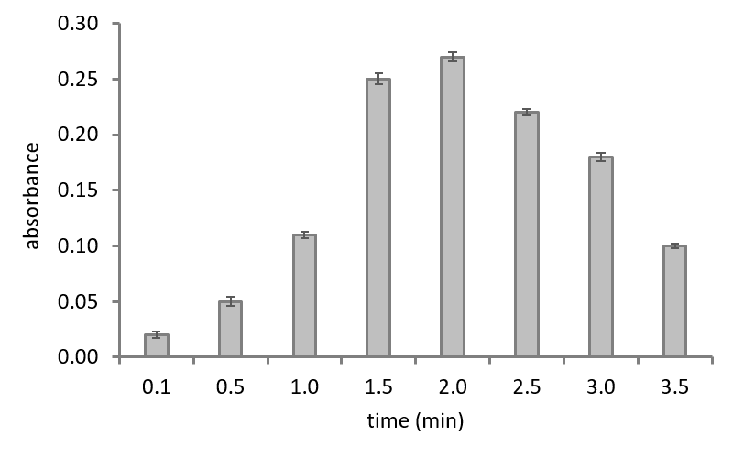
Figure 1 Figure caption (Font size 11 pt., Regular, Justify, Exactly 16).

Table 1 Table caption (Font size 11 pt., Regular, Justify, Exactly 16).

Experiment | Time (min) | Concentration (mM) | Absorbance
1 | x | x | x
2 | x | x | x
3 | x | x | x

Figures and tables should be placed relevant to the text.

4. Conclusion (Font size 11 pt., Bold, Exactly 16, left justify)

Conclusion section is an optional. It can be combined to the discussion part. In this part, the results are summarized to show that if the finding results agree with the objective. Author should link the conclusion with the goal of the study. (Font size 11 pt., Regular, Justify, Exactly 16, Tab 1.27 cm)

5. Acknowledgements (Font size 11 pt., Bold, Exactly 16, left justify)

Acknowledgements of people, grants, funds, etc. People who are in the author list shall not be in the acknowledgement section. (Font size 11 pt., Regular, Justify, Exactly 16, Tab 1.27 cm)

6. References (Font size 11 pt., Bold, Exactly 16, left justify)

References should be cited in numerical order. In case a reference is cited more than once, the same number should be used each time. You are suggested to use the standard abbreviation of a journal’s name. If you are unsure, please use the full journal’s name. List of reference should be in the following form:

Journal article
[1] Matabaro, E., Ishimwe, N., Uwimbabazi, E. and Lee, B. H. 2017. Current immunoassay methods for the rapid detection of aflatoxin in milk and dairy products. Compr. Rev. Food. Sci. F. 18: 808-820.

Book
[2] Steel, R. G. D. and Torrie, J. H. 1980. Principles and Procedures of Statistics: A Biometrical Approach. 2nd edn. McGraw-Hill Book Company, New York, New York.

Dissertation
[3] Lebogang, L. 2014. Biosensor-based methods for detection of microcystins as early warning systems. Ph.D. Thesis, Lund University, Lund.

Proceeding
[4] Goodband, R. D., Tokach, M. D., Dritz S. S. and Nelssen, J. L. 1995. Practical Nutrition for the Segregated Early Weaned Pig. In: Proceeding of the 1995 Saskatchewan Pork Industry Symposium, Saskatoon, Saskatchewan. pp. 15-22.

Online document
[5] Aflatoxins: https://www.who.int/foodsafety/FSDigest_Aflatoxins_EN.pdf (Accessed 21 Sep 2019).

